**Projections**

**Definitions**

**Projection:** In Gis Projection refers to the mathematical transformation that takes spherical coordinates (longitude and latitude) and converts them into planar coordinate system i.e. XY coordinates. This simply enables you to create maps that accurately show distances, areas or directions.

**Important Parameters in Map Projections:**

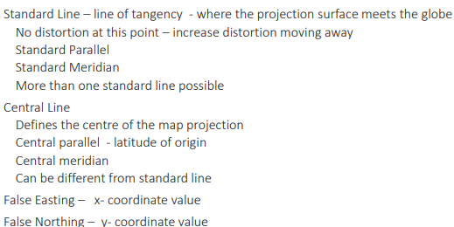

**Types of Projections:**

**Cylindrical Map Projection:** This is the projection in which the surface features of the earth/globe are represented as if they are projected onto a cylinder which is positioned with the globe centered horizontally inside the cylinder. The distance and sizes of the equator is preserved. The biggest advantage of a Cylindrical Map Projection is that due to a grid (formed by parallels and meridians) position location is easier. The disadvantage is the distortion of distance and sizes near the poles.

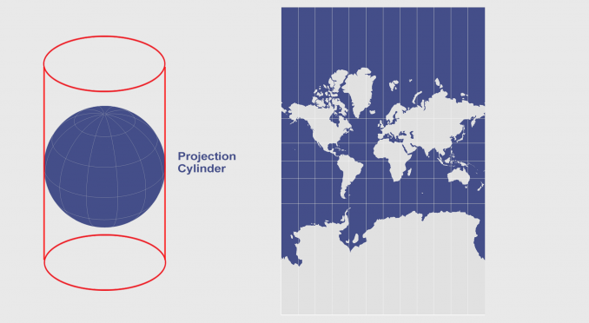

Figure 1: Cylindrical Projection

**Conical Map Projection:** This is the projection in which the surface features of the earth/globe are represented as if they are projected onto a cone which is positioned on the globe along a parallel (a line of equal magnitude). If the cone is flattened the conic projection then represents a semicircular map with area below the apex of the cone at its center. The distortions in this projection increases towards north and south of the parallels and the distortions increase a lot on the poles such that sometimes the poles are excluded from these projections. The conic projection is generally used for mid latitude zones with an east-west orientation.

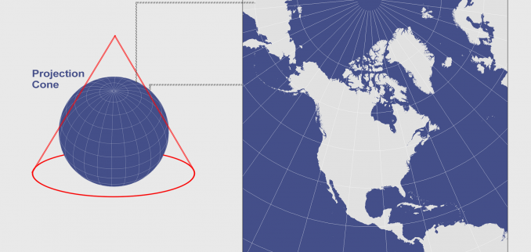

Figure 2: Conical Projection

**Azimuthal Map Projection:** This is the projection in which the surface features of the earth/globe are represented as if they are projected onto a flat surface. This projection creates a circular map with a chosen point which is tangent to the flat surface at its center. The directions in this projection are preserved while the shapes and distances are distorted from the center.

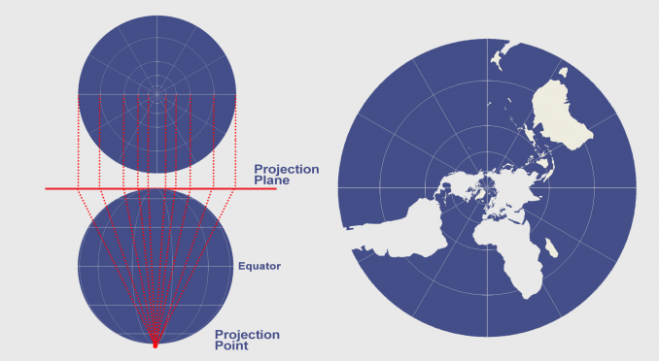

Figure 3: Azimuthal Projection

**Equal Area Projection:** A map Projection that preserves the true size of the earth features. It preserves area but it distorts shapes, angels and is not conformal.

**Conformal Projection:** A map Projection that preserves the shape of the earth features and distorts the size of the said features.

**Equidistance Projection:** A map Projection that preserves the distance and distorts shape and area of the earth features.

**Choice of Map projection for Pakistan:**

The choice of Map projection generally depends upon the purpose of your map, this purpose helps you determine which spatial quantity you want your map to preserve and the quantity you want the map to not preserve. For example for large scale surveying and mapping conformal projection is used.

Some Examples.

**UTM and Transverse Mercator projection:** A map projection that is conformal and it is used for mapping areas smaller than a few degrees longitudinally such as a state or a country. Pakistan lies in zone 41N, 42N and 43N.

**Lambert Conical Conformal Projection:** It is a secant projection such that it has two standard parallels, the distortion of shapes and areas increases as you move away from the standard parallels the directions however are reasonably accurate. Directions are preserved throughout due to conformality. Grid system composed of 8 grids are utilized to represent Pakistan, India and Burma, these Grids are also referred to as Zones (which have unique set of parameters). Pakistan is covered completely by Grid-1 and Grid-2A.

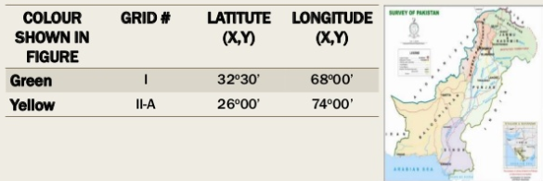

Figure 4: Grids of LCCP

References.

<https://gisgeography.com/equal-area-projection-maps/>

<https://geospatialclub.wordpress.com/2016/04/18/utm-zones-pakistan>

<https://docs.roguewave.com/en/visualization/current/views/views.html#page/Options/projections.59.06.html>

<https://desktop.arcgis.com/en/arcmap/latest/map/projections/lambert-conformal-conic.htm>